**Basavarajeswari group of institutions**

# Ballari Institute of Technology & Management

**AUTONOMOUS INSTITUTE UNDER VISVESVARAYA TECHNOLOGICAL UNIVERSITY JNANASANGAMA,**

**BELAGAVI 590018**

**INTERNSHIP**

**Report On**

**Sport Psychology Appointment System**

Submitted in partial fulfillment of the requirements for the award of degree of

# Bachelor of Engineering In

## COMPUTER SCIENCE AND ENGINEERING

### Submitted by

### PRIYANKA HORAPYATI

**3BR22CS129**

### Internship Carried Out

### By

**EZ TRAININGS & TECHNOLOGIES PVT.LTD**

**HYDERABAD**

**Internal Guide External Guide**

**Mrs. MADHURI A Mr. BALAJI SRINIVASAN**

**Assistant Professor ,CSE Sr. Faculty**

**Ms. SAMEENA YASMEEN**

**Supervisor ,CSE**

#### BALLARI INSTITUTE OF TECHNOLOGY & MANAGEMENT

NACC Accredited Institution*

**(RecognizedbyGovt.ofKarnataka,approvedbyAICTE,NewDelhi&AffiliatedtoVisvesvarayaTechnologicalUniversity,Belagavi)**

**"JnanaGangotri"Campus,No.873/2,Ballari-HospetRoad,Allipur,Ballar1-583104(Karnataka)(India)Ph:08392–237100/237190,Fax:08392–237197**

### 2023-2024

**Basavarajeswari group of institutions**

## BALLARI INSTITUTE OF TECHNOLOGY & MANAGEMENT

**Autonomous institute under VISVESVARAYA TECHNOLOGICAL UNIVERSITY JNANASANGAMA,**

**BELAGAVI 590018**

NACC Accredited Institution*

**(RecognizedbyGovt.ofKarnataka,approvedbyAICTE,NewDelhi&AffiliatedtoVisvesvaraya Technological University, Belagavi)**

**"JnanaGangotri"Campus,No.873/2,Ballari-HospetRoad,Allipur,**

**Ballar1-583104(Karnataka)(India) Ph:08392–237100/237190,Fax:08392–237197**

## DEPARTMENT OF COMPUTER SCIENCE AND ENGINEERING

**CERTIFICATE**

This is to certify that the Internship entitled **“Sport Psychology Appointment System”** has been successfully completed by **PRIYANKA HORAPYATI** bearing USN **3BR22CS129** a bonafide student of Ballari Institute of Technology and Management, Ballari. For the partial fulfillment of the requirements for the **Bachelor’s Degree in Computer Science and Engineering** of the VISVESVARAYA TECHNOLOGICAL UNIVERSITY, Belagavi during the academic year 2023-2024.

#### Signature of Internship

#### Co-ordinators

**Signature of HOD**

**Mrs. MADHURI A Dr. R N KULKARNI**

**Assistant Professor ,CSE Professor & HOD(CSE)**

&

**Ms. SAMEENA YASMEEN**

**Supervisor ,CSE**

**DECLARATION**

I, **PRIYANKA HORAPYATI,** second year student of Computer Science and Engineering, Ballari Institute of Technology, Ballari, declare that Internship entitled **Sport Psychology Appointment System** is a part of Internship Training successfully carried out by **EZ TECHNOLOGIES & TRAININGS PVT.LTD, Hyderabad** at “**BITM, BALLARI”.** This report is submitted in partial fulfillment of the requirements for the award of the degree, Bachelor of Engineering in Computer Science and Engineering of the Visvesvaraya Technological University, Belagavi.

**Date : Signature of the Student**

**Place :**

**ACKNOWLEDGEMENT**

The satisfactions that a company the successful completion of my internship on “Sport Psychology Appointment System” would be incomplete without the mention of people who made it possible, whose noble gesture, affection, guidance ,encouragement and support crowned my efforts with success. It is my privilege to express my gratitude and respect to all those who inspired me in the completion of my internship.

I am grateful to my respective coordinators “**Mrs.Madhuri A(Asst.prof,CSE) and Ms.Sameena Yasmeen (Supervisor,CSE)**” for their noble gesture ,support co-ordination and valuable suggestions given to me in the completion of Internship.

I also thank **Dr. R N Kulkarni,** HOD , Department of **Computer Science and Engineering** for extending all his valuable support and encouragement.

**Table of Contents**

|  |  |  |
| --- | --- | --- |
| **Chapter No.** | **Chapter Name** | **Page No.** |
| **1** | **Company Profile** | **1** |
| **2** | **Day to day activity(student diary extract)** | **2** |
| **3** | **Abstract** | **3** |
| **4** | **Introduction of the project** | **4** |
| **5** | **Description** | **5** |
| **6** | **Flow chart** | **6** |
| **7** | **Output** | **7-9** |
| **8** | **Conclusion** | **10** |
| **9** | **References** | **11** |

# COMPANY PROFILE

## Company Name : EZ Trainings and Technologies Pvt. Ltd.

### Introduction:

EZ Trainings and Technologies Pvt. Ltd. is a dynamic and innovative organization dedicated to providing comprehensive training solutions and expert development services. Established with a vision to bridge the gap between academic learning and industry requirements, we specialize in college trainings for students, focusing on preparing them for successful placements. Additionally, we excel in undertaking development projects, leveraging cutting-edge technologies to bring ideas to life.

### Mission:

Our mission is to empower the next generation of professionals by imparting relevant skills and knowledge through specialized training programs. We strive to be a catalyst in the career growth of students and contribute to the technological advancement of businesses through our development projects.

### Services:

**College Trainings:**

* Tailored training programs designed to enhance the employability of students.
* Industry-aligned curriculum covering technical and soft skills.
* Placement assistance and career guidance.

### Development Projects:

* End-to-end development services, from ideation to execution.
* Expertise in diverse technologies and frameworks.
* Custom solutions to meet specific business needs.

**Locations:** Hyderabad | Delhi NCR

At EZ Trainings and Technologies Pvt. Ltd., we believe in transforming potential into excellence

1

IN

## ABSTRACT

* The Sport Psychology Appointment System is a Python solution designed to manage appointments, schedule sessions for athletes, and handle feedback efficiently
* It employs class definitions for appointments and the system, CRUD operations, and utilizes data structures like lists or dictionaries to manage collections of appointments.
* Class Definitions:Appointment - Represents individual appointments, storing relevant details such as date, time, athlete ID, and session feedback

Appointment_system - appointment management operations, including CRUD functionalities and session scheduling.

* Methods:CRUD Operations - Provides functionalities for creating, reading, updating, and deleting appointment data.
* Data Structures: Utilizes lists or dictionaries to efficiently manage collections of appointments, ensuring easy access and manipulation of data.
* Testing: Utilizes Python's unittest framework to conduct comprehensive testing, ensuring the correctness and reliability of system functionalities

3

## INTRODUCTION OF THE PROJECT

* In this project, we introduce a groundbreaking Sports Psychology Appointment System designed to revolutionize the way athletes access mental support and guidance.
* Recognizing the critical role of psychological well-being in athletic success, this system aims to streamline the process of scheduling appointments with sports psychologists, providing athletes with timely and tailored interventions to optimize their performance
* In the realm of sports performance, mental conditioning plays a pivotal role in an athlete's success. To address the unique psychological needs of athletes and optimize their mental well-being, the development of a Sport Psychology Appointment System is paramount
* This Proof of Concept (POC) endeavors to pioneer a streamlined approach to scheduling sport psychology sessions and managing session feedback, thereby empowering athletes to achieve peak performance levels.

## 

4

## MODULE DESCRIPTION

1. Appointment:

* In this class we define __init__() method to initialize the attributes like appointment_id , athlete_id , date_time , notes , feedback

1. Appointment_system:

* The module encapsulates the functionalities required to create, read, update and delete appointment data, ensuring the CRUD Operations
* Create_appointment():
* Allows users to create a new appointment and stores it in the appointments dictionary. Also writes the appointment details to a text file named "appointments.txt".
* Get_appointment():
* Retrieves and displays appointment details based on the provided athlete ID.
* Update_appointment():
* When correspondence athlete ID is given it Updates an existing appointment's details such as appointment ID, date and time, and notes. Updates the details in the appointments dictionary and the "appointments.txt" file.
* Delete_appointment():
* Deletes an appointment based on the provided athlete ID. Updates the appointments dictionary and the "appointments.txt" file accordingly.
* Manage_session_feedback():
* This module handles the management of session feedback, facilitating continuous improvement of sports psychology services.
* Schedule_sport_psychology_session():
* Enables users to schedule a new sport psychology session and adds it to the appointments dictionary. Also appends the details to the "appointments.txt" file.

5

**FLOWCHART**

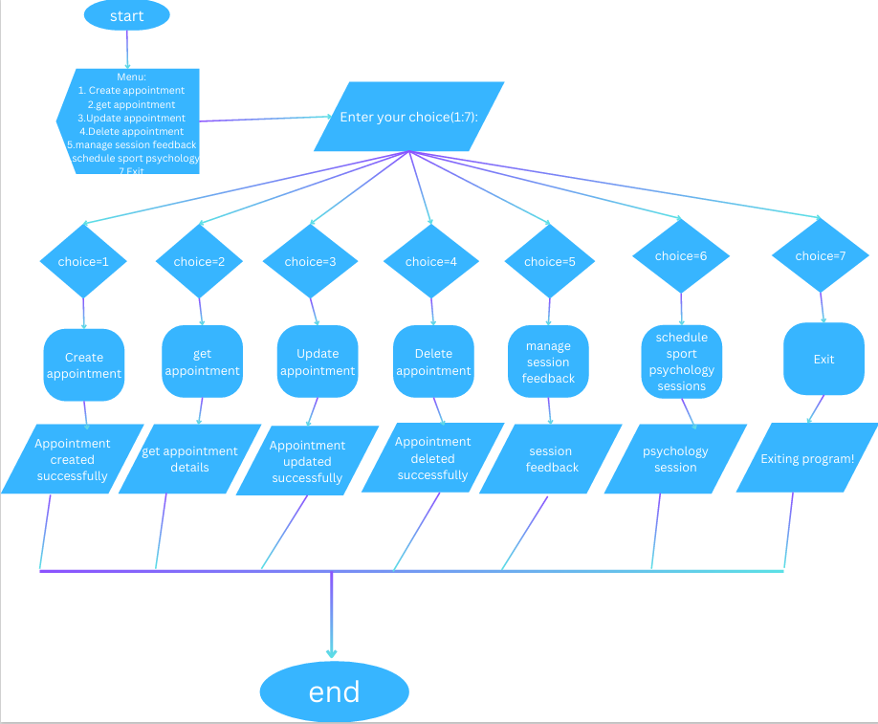

**OUTPUTS:**

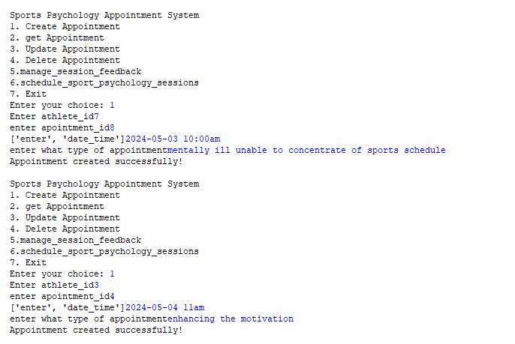

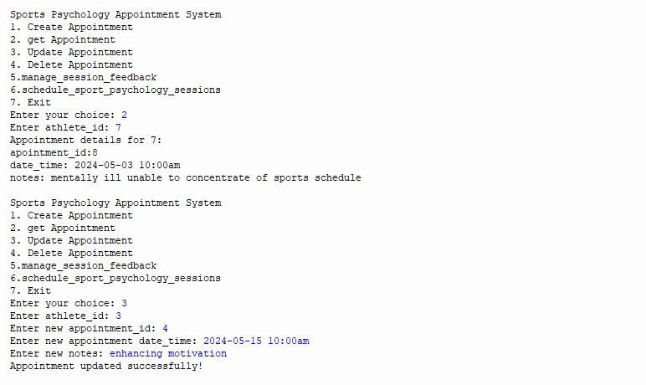

7

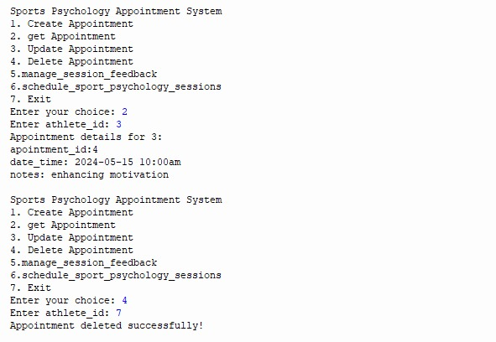

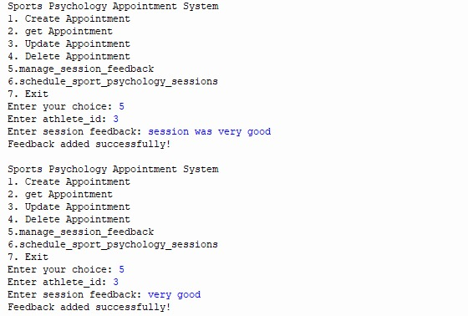8

#### 

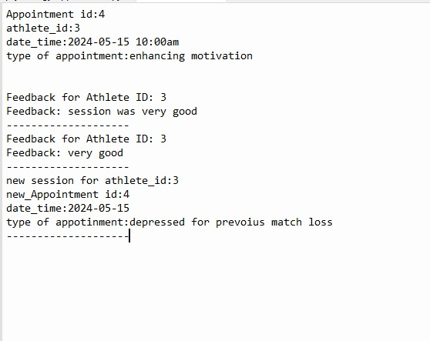

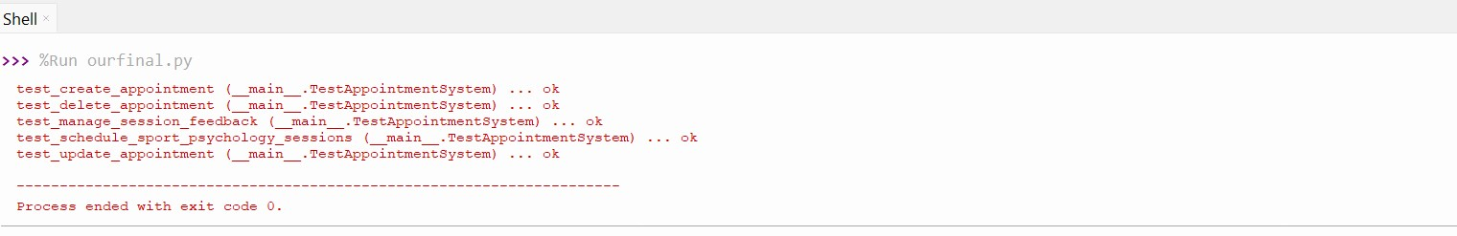

9

**CONCLUSION**

* This Sport psychology Appointment System lays the groundwork for an efficient system to support athletes' mental well-being and performance. By offering structured appointment management and feedback mechanisms, it fosters a proactive approach to mental health support within sports organizations.
* Additionally, it fosters accountability and ensures timely assistance for athletes, ultimately contributing to their overall well-being and success

10

**BIBLIOGRAPHY**

1. **Google**
2. **www.programiz.com**
3. **Geeks for Geeks**

11